Ibn Battuta and Zheng He: Brave Travelers of the Medieval Era
By: Sophia Bagnall

Introduction:
Everybody knows the explorer Christopher Columbus, but how many in the Western World have heard of Ibn Battuta or Zheng He? Often we learn about exploration from the West to the East; however, there are many famous explorers who went East to West. Learning about the journeys of two Muslim travelers across the Indian Ocean world shows different perspectives than what we would learn by studying a more well-known Western figure like Marco Polo. They had vastly different goals in their travels; Zheng He was on a diplomatic mission and Ibn Battuta wanted to see the entire Muslim world. The goals of travelers from Europe were to find lands to conquer and convert. Western travelers typically framed their experiences as exploring "the wonders of the Far East", something exotic and unusual where treasure could be found. From the writings of Ibn Battuta and Zheng He, we can see that both men made an effort to document the local cultures and customs of people they met while traveling in a way that did not paint these societies as uncivilized. Instead, they commiserated with the locals as equals.
Ibn Battuta was a famous explorer in the Medieval Era and a Sunni Muslim who left his homeland intending to complete the hajj, the holy pilgrimage to Mecca. Ibn Battuta was raised by Islamic judges, or qadis, who use Sharia to inform their legal decisions. Ibn Battuta became a qadi himself and worked as a judge in Delhi, India. Ibn Battuta is considered one of the most accomplished travelers of all time, and his journey took him through what are now 44 countries in and around the Indian Ocean within a span of approximately 30 years. He wrote extensively about local societies, the food he ate, and the struggles he faced on his journey. Due to his achievements in the exploration of the Muslim world, Ibn Battuta is a household name in many parts of the Middle East.
Ibn Battuta’s writings allow readers to learn about the Indian Ocean region through his visits to Muslim lands. During his travels, Ibn Battuta is shown great hospitality, which is customary in the Middle East, especially when someone is completing the hajj. This makes Ibn Battuta’s experience relatable in that it shows readers what it would have been like traveling as a Muslim in the Middle Ages. It enables him to connect to the people he meets in a meaningful way, and as an Islamic judge he was able to find work in places like India. He continued to travel after completing his first hajj, and returned to Mecca 3 more times over the next 30 years. His experiences and knowledge of the region were unparalleled after completing his travels.
Zheng He, an admiral for the Yongle Emperor in China, was originally named Ma Sanbao. The family name "Ma" was derived from the Chinese version of Muhammad. Zheng He was a Muslim and a eunuch. When the Ming Dynasty conquered the land of his family, Zheng He was taken captive, castrated, and sent to the army. He made friends at court and distinguished himself as a skilled junior officer. When the Prince of Yan took the throne, he changed his own name to Emperor Yongle (meaning perpetual happiness) and changed Ma He’s name to Zheng He (Zheng was the name of the Emperor's favorite war horse). Zheng He’s name was changed as a reward for his accomplishments in battle, which helped Emperor Yongle win the throne. Zheng He was selected to be commander of the empire's fleet of ships. As an accomplished admiral, he commanded 317 ships and a large army. In addition, he was the captain of the largest wooden ships ever built as part of the treasure fleet. The treasure fleet was a number of impressive ships which carried riches and gifts as part of a Chinese diplomatic mission in the Indian Ocean. The stated goal of the fleet was to increase trade for the Chinese Empire and project Chinese power.
Learning about Zheng He teaches students a lot about the political atmosphere in the Indian Ocean during his time. He was a eunuch who rose through the ranks of the Chinese court to command the most impressive fleet the Indian Ocean and the world had ever seen. China had an age of exploration in the early 15th century. The Chinese were trading over much of the known world long before the arrival of Europeans in the 16th century. This demonstrates that China was just as important and powerful in the Medieval Era as places in Europe. Archeological excavations discovered jewels from Sri Lanka and artifacts from the Middle East, indicating the role of China as one of the major players in Indian Ocean trade. These excavations discovered evidence of a number of high courts in China, demonstrating the power and organization that the Chinese empire employed during their rule. The Chinese empire in the 15th century was wealthy, international, and powerful. The first Qur'an created in China came from Beijing in 1401. In addition, a number of Muslim populations lived in China, brought there by trade. This exemplifies the tolerance the Chinese government showed towards other religions during the Medieval Era. Zheng He was an integral part of fostering China’s relationships with other rulers in the Indian Ocean as an accomplished diplomat and trader.
Reading about these travelers offers a viewpoint distinct from the commonly accepted narratives of those from the West who traveled to the East. Studying these Muslim travelers shows us a different perspective on the lands they visited and people they saw. These were two of the most accomplished men of their era, and their names are still remembered by many in the world today. These narratives tell us not only about the travelers themselves, but also about the people and places that they visited in detail. By looking at history through a new lens that is Eastern centric, it is possible to gain a more comprehensive understanding of the Indian Ocean, the Middle East, and Asia during the Medieval Era.
Learning Objectives:
- Learn about the travelers Ibn Battuta and Zheng He and be able to demonstrate knowledge of their experiences.
- Challenge preconceived notions held about the Middle East and Asia.
- Understand the importance of viewing history through more than one lens when researching using primary and secondary sources; this will give you a more accurate representation of the people or places you are studying.
Age Group:
- Advanced, IB, or AP High School students
Materials:
- A computer for each student
- A projector
- A whiteboard (optional)
- Enough copies of the worksheets for everyone
- Enough copies of the excerpt from Orientalism for everyone
Duration:
- Two 60-minute class periods.
Homework Before the Lesson:
- Have students read these two biographies on Ibn Battuta and Zheng He from the Mariners Museum website in the Ages of Exploration section to familiarize themselves with the travelers before beginning the lesson. They should also view the galleries at the bottom of the pages. Follow the links below to find the biographies.
- https://exploration.marinersmuseum.org/subject/zheng-he/
- https://exploration.marinersmuseum.org/subject/ibn-battuta/
Engage Day 1: (10 Minutes)
- Show this video from Crash Course on YouTube. Time: 10:37
- This video compares one of our travelers (Zheng He) with travelers that the students may already be familiar with. This will give students perspective on his accomplishments.
- Columbus, de Gama, and Zheng He! 15th Century Mariners
- https://www.youtube.com/watch?v=NjEGncridoQ&t=120s
Reading Discussion Day 1: (10 Minutes)
- What are some similarities and differences that you noticed between Ibn Battuta and Zheng He?
  - Similar:
    - Muslim
    - Completed the hajj
    - Traveled in Asia, the Middle East, and Africa
    - Still famous - Ibn Battuta in the Middle East and Zheng He in China
    - Traveled by sea
    - Spent time in high courts in foreign lands
  - Different:
    - Zheng He worked for the Chinese government and Ibn Battuta traveled for religious purposes and his own
    - Ibn Battuta often traveled on his own, on land, or in a caravan while Zheng He was the commander of a fleet of ships
    - Ibn Battuta traveled primarily to Muslim regions and Zheng He spent more time in Asia
    - Ibn Battuta became a qadi and Zheng He was an admiral
- Who would you prefer to travel with? Why?
Explore Day 1: (20 Minutes)
- Write or project the learning objectives.
  - Talk to students about primary and secondary sources:
    - Primary sources are created by a participant or witness either during the period being studied or after the events transpired. They reflect the individual viewpoint of a participant or observer. Primary sources enable the researcher to get as close as possible to what actually happened during an historical event or time period. It is important however to not take these sources at face value. Here are some questions to ask about primary sources to get the full picture:
      - When was this source created?
      - Who created it? What is their position in society?
      - What was the original purpose of this source? What was its intent?
      - Who is the intended audience of the source? How does this influence the way information is presented?
      - How has the meaning of the source changed over time?
      - How might a historian use this source as a piece of evidence?
    - A secondary source is a work that interprets or analyzes a historical event or phenomenon. It is generally at least one step removed from the event and is often based on primary sources. Examples include: scholarly or popular books and articles, reference books, and textbooks.
    - When reviewing primary and secondary sources, it is important to examine the background of who wrote it, and how that might affect their observations of the event, place, or person they are writing about. One way to get a more objective and well-rounded view would be to look at multiple different primary and secondary sources from a variety of perspectives. This will mitigate the effect of the biases of the author, and allow researchers to develop a better understanding of the event, place, or person they are studying.
- Divide students into three groups: Group 1, Group 2, and Group 3.
- Have students go to the Indian Ocean in World History website (http://indianoceanhistory.org/) and click on Maps > Medieval Era. Enough worksheets should be printed for each student.
- Group 1 will fill out Worksheet 1:
  - Found on page 12 of this document.
- Group 2 will fill out Worksheet 2:
  - Found on page 13 of this document.
- Group 3 will fill out Worksheet 3:
  - Found on page 14 of this document.
- Write or project the icons the students should look for.
Icons:
Ibn Battuta-
- Ibn Battuta in Morocco
- Ibn Battuta in East Africa
- Ibn Battuta in the Arabian Sea
- Ibn Battuta in the Maldives
- Ibn Battuta on Chinese Ships
- Ibn Battuta in the Malabar Coast
Zheng He-
- Zheng He, First Expedition
- Zheng He, Third and Fourth Ming Expeditions
- Zheng He, Fifth, Sixth, and Seventh Ming Expedition
Day 1 Discussion: (20 Minutes)
- Either select groups or have students get into groups where each member has a different worksheet. They should take 15 minutes to share the information from their worksheets within their group.
- Have all the students who prefer primary sources raise their hand. Ask for volunteers to explain why they feel that way or call on a few students. Now ask those who did not raise their hand why they prefer secondary sources.
- Ask students to share the most interesting or surprising thing they learned from the icons they were assigned.
Day 1 Homework:
- Students will read an excerpt from the introduction of Edward Said's Orientalism. The full PDF can be found here:
- https://monoskop.org/images/4/4e/Said_Edward_Orientalism_1979.pdf
- The excerpts can be found on pages 10 and 11 of this document, the reading will need to be printed for each student.
Beginning of Day 2: (5 Minutes)
- Show this video on YouTube explaining Orientalism. Time: 4:52
- This is meant to simplify the reading and provide an overview of the concept of Orientalism.
- Orientalism
- https://www.youtube.com/watch?v=UI-cbPX8hoI
Orientalism Day 2: (25 Minutes)
- Have students take 5 minutes to review the text. In their groups from sharing about the worksheets, students should take 10 minutes to pick out what they think is the most important passage and why, and then share these passages with the class.
Orientalism Discussion for Day 2: (30 Minutes)
- If these lines aren't selected they should still be addressed:
  - "Have accepted the basic distinction between East and West as the starting point for elaborate theories, epics, novels, social, descriptions, and political accounts concerning the Orient, its people, customs, mind, destiny, and so on." (¶ 1)
    - Meaning: The divisions between East and West are man-made and have been accepted as fact by scholars, authors, and others alike. Cultures described as "other" by outsiders with imperial interests, like Great Britain, France, and the United States, have impacted how people write and think about the East even if they have never visited themselves.
  - "It also tries to show that European culture gained in strength and identity by setting itself off against the Orient as a sort of surrogate and even underground self." (¶ 2)
    - Meaning: By making the Orient "other," Western culture also made the Orient "less than," and this way of thinking has persisted through the centuries to affect subconsciously how many today think about the East.
  - "All academic knowledge about India and Egypt is somehow tinged and impressed with, violated by, the gross political fact." (¶ 3)
    - Meaning: The academic knowledge by the West and for the West does not accurately represent the Orient or the East. Today when reading about a place or a people, it is important to take into account who is writing about it. What are their internal biases? Is there another source with a different perspective? Work towards not taking material at face value and regarding it as objective, keeping in mind that everyone is influenced by their upbringing.
  - "That he comes up against the Orient as a European or American first, as an individual second." (¶ 3)
    - Meaning: We typically have biases that we do not recognize. Our point of view is shaped by where we grew up and what we are familiar with. It is also shaped by what we have been taught and the actions of our country of origin. It is impossible to separate ourselves from that, but what we can do is recognize that our point of view has been influenced by it. To recognize this can help us attempt to see things from a perspective that is not our own and mitigate the effects of cursory judgements.
- Discussion points for overall takeaways from Orientalism and how that relates to Ibn Battuta and Zheng He:
  - Explain the idea of the “other”.
    - This Orientalized "Other" is nothing except a fictional Western construct. The West found it convenient to lump together a vast number of different societies - containing cultures as different as Saudi Arabia, India, and China - under one umbrella, calling them all "the Orient." Doing so makes them easier to control.
  - What perceptions of Middle Eastern people are sustained and perpetuated through the lens of Orientalism? How has learning this challenged your perspective?
    - “Mysterious” - “exotic” - “barbaric” - “terrorist” - “sexist”. These are common stereotypes that people hold about the Middle East. Learning how this narrative has been crafted through colonialism over several hundred years should help people examine their own internal biases about the Middle East and its people.
  - How did the Orientalist view originate and spread? What is its history?
    - Consider how colonization and colonialism have assisted in this process. Also how differences of power contributed to the spread.
  - Given what you now know about Orientalism, why is it important to read the stories of Ibn Battuta and Zheng He?
    - These stories are valuable resources when studying the Middle East and Asia that offer an alternative to the Western perspective. By reading the accounts of Eastern travelers, our subconscious biases are more challenged than if we were to read an account by a traveler who viewed the places he visited from a Western-centric lens. Additionally, these two men are accomplished and well known travelers in their own right.
  - How can we use the knowledge that we now have about Orientalism going forward?
    - When watching movies, the news, or TV shows, it is important to recognize when the images are just confirming a bias that we already hold about the so called “East.” In addition, when researching places or people that live or have existed in the region, it is imperative to recognize the biases of the author, and mitigate that wherever possible. One good way to do this is find sources like Ibn Battuta or Zheng He. Although many people see scholarship as objective, it is essential to realize that everything is subjective and is influenced by that person's life or background.

Orientalism by Edward Said- the introduction:
Related to this academic tradition, whose fortunes, transmigrations, specializations, and transmissions are in part the subject of this study, is a more general meaning for Orientalism. Orientalism is a style of thought based upon an ontological and epistemological distinction made between "the Orient" and (most of the time) "the Occident." Thus a very large mass of writers, among whom are poets, novelists, philosophers, political theorists, economists, and imperial administrators, have accepted the basic distinction between East and West as the starting point for elaborate theories, epics, novels, social, descriptions, and political accounts concerning the Orient, its people, customs, mind, destiny, and so on. This Orientalism can accommodate Aeschylus, say, and Victor Hugo, Dante and Karl Marx. (pg. 2-3).
Moreover, so authoritative a position did Orientalism have that I believe no one writing, thinking, or acting on the Orient could do so without taking account of the limitations on thought and action imposed by Orientalism. In brief, because of Orientalism the Orient was not (and is not) a free subject of thought or action. This is not to say that Orientalism unilaterally determines what can be said about the Orient, but that it is the whole network of interests inevitably brought to bear on (and therefore always involved in) any occasion when that peculiar entity "the Orient" is in question. How this happens is what this book tries to demonstrate. It also tries to show that European culture gained in strength and identity by setting itself off against the Orient as a sort of surrogate and even underground self. (pg. 3).
I do not want to press all this any further on general theoretical grounds: it seems to me that the value and credibility of my case can be demonstrated by being much more specific, in the way, for example, Noam Chomsky has studied the instrumental connection between the Vietnam War and the notion of objective scholarship as it was applied to cover state-sponsored military research. Now because Britain, France, and recently the United States are imperial powers, their political societies impart to their civil societies a sense of urgency, a direct political infusion as it were, where and whenever matters pertaining to their imperial interests abroad are concerned. I doubt that it is controversial, for example, to say that an Englishman in India or Egypt in the later nineteenth century took an interest in those countries that was never far from their status in his mind as British colonies. To say this may seem quite different from saying that all academic knowledge about India and Egypt is somehow tinged and impressed with, violated by, the gross political fact- and yet that is what I am saying in this study of Orientalism. For if it is true that no production of knowledge in the human sciences can ever ignore or disclaim its author's involvement as a human subject in his own circumstances, then it must also be true that for a European or American studying the Orient there can be no disclaiming the main circumstances of his actuality: that he comes up against the Orient as a European or American first, as an individual second. And to be a European or an American in such a situation is by no means an inert fact. It meant and means being aware, however dimly, that one belongs to a power with definite interests in the Orient, and more important, that one belongs to a part of the earth with a definite history of involvement in the Orient almost since the time of Homer. (pg.11).

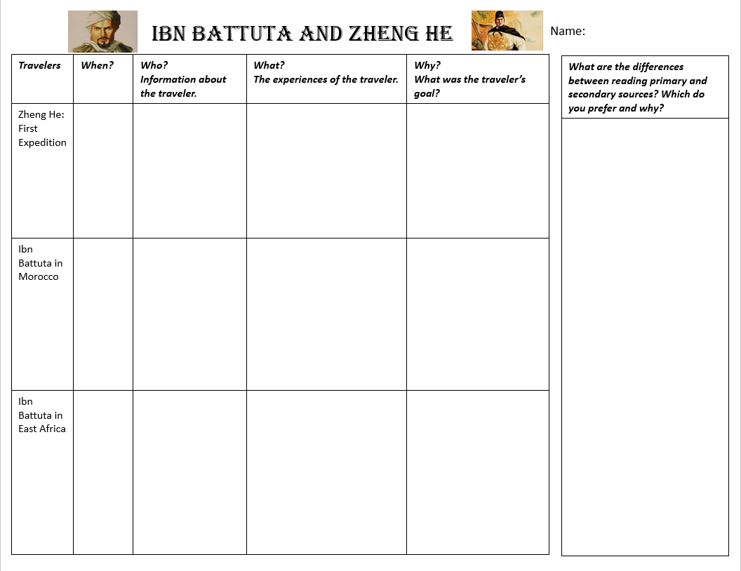
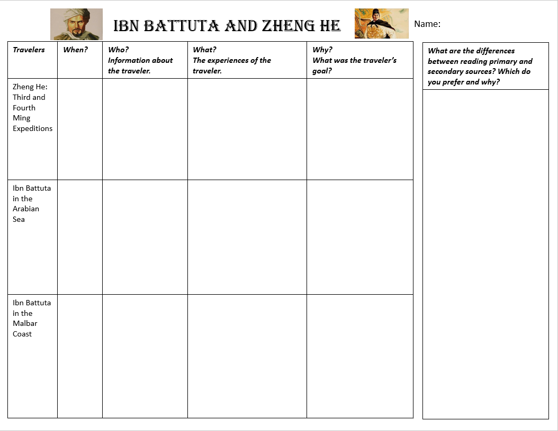
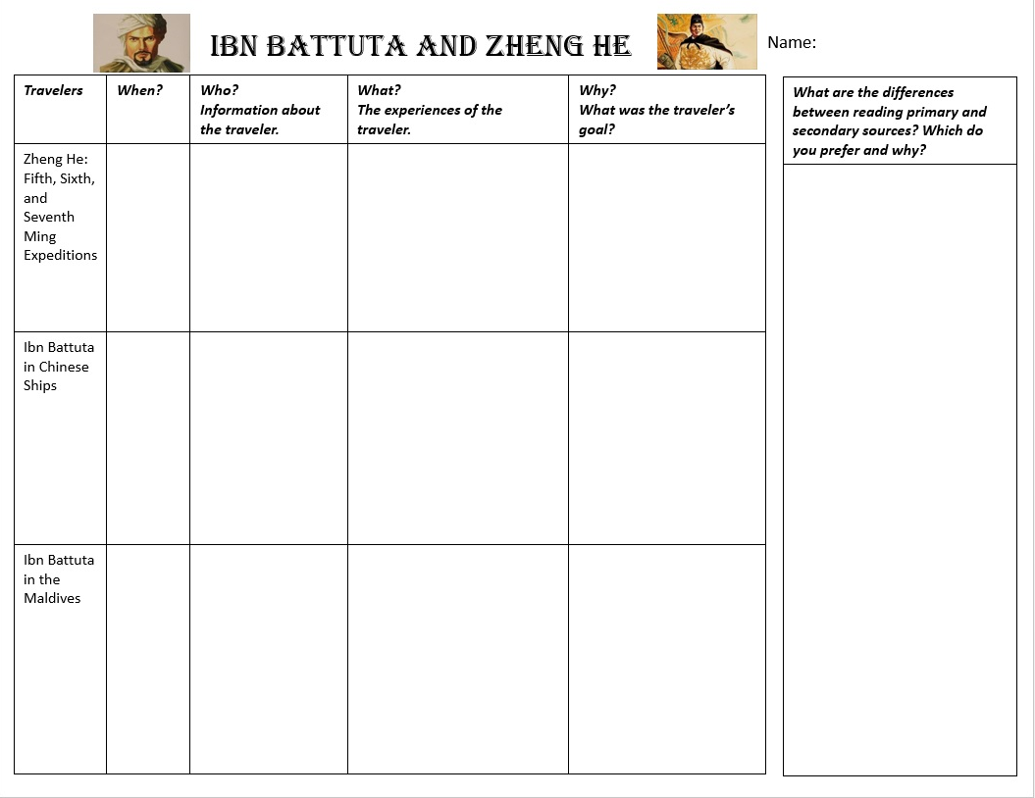

The hajj is a religious journey that all able Muslims are required to take to the holy city of Mecca and is one of the five pillars of faith. The other four pillars of faith are bearing witness that there is no God but God and Muhammad is his messenger (shahada), praying five times a day (salat), giving charity (zakat), and fasting during the month of Ramadan (sawm).
Sharia is Islamic canonical law based on the teachings of the Quran and the traditions of the Prophet. There are four sources of sharia: the Quran, sunnah (authentic hadith - sayings of the prophet), qiyas (analogical reasoning), and ijma (juridical consensus).
A eunuch is someone who has been castrated. This is often done so that male servants can be around royal women without fear of the bloodline being disrupted.
Ontological: showing the relations between the concepts and categories in a subject area or domain.
Epistemological: relating to the theory of knowledge, especially with regard to its methods, validity, and scope, and the distinction between justified belief and opinion.
The Orient: the East (the Middle East, North Africa, Asia, and Southeast Asia)
The Occident: the West (Europe and America)
Orientalism: Orientalism is a postcolonial discourse that considers the Eurocentric construction of an artificial binary opposition between the Western world and the Eastern world. "Orientalism," as defined by Edward Said, is the Western attitude that views Eastern societies as exotic, primitive, and inferior. Basically, an Orientalist mindset centers the Western (European/American) world and views the Eastern world as "the other."

